"Space: Completeness and Emptiness”
An Ashtanga Yoga Weekend with Arnaud Kancel
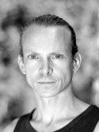
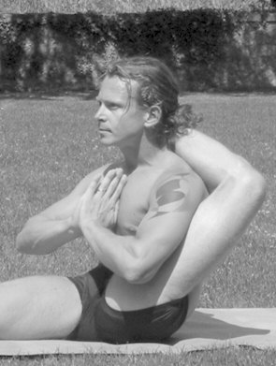
Friday, January 11 – 13, 2013
at Haus Am Becheler, Bereldange

FRIDAY EVENING - 18:30-20:30
"Awakening the core of the body"
In this session, we will study the energy of the postures that make up the Ashtanga Yoga practice. After breaking down the different series, we will approach the components and scope of posture practice.

SATURDAY MORNING 9:00-11:00
"Free flow"
We will practice the primary series using techniques that allow us to move into the postures so that they can be executed harmoniously and in rhythm to the breath.

SATURDAY AFTERNOON 14:30-16:30
"Roots and alignments"
The quality of the posture is partly determined by a firm base. Moreover, there is a physiological link between the way we place our body, the energy of motion and our breathing capacity. This session will lay out some principles that can be applied to all postures in order to secure additional power and ease when practising Ashtanga Yoga.

SUNDAY MORNING 9:00-11:00
"Jamboree"
This session uses Ashtanga Yoga and variations to open the body and facilitate breathing, a happy session based on the primary and secondary series that will keep us full of energy.

SUNDAY AFTERNOON 14:30-16:30
"Unity"
Recap on what we studied during the weekend, sometimes using different approaches for a greater understanding.

Price: 150 Euros Location: Haus am Becheler, Bereldange

Enrollment: Payment required to reserve your place. The payment is fully refundable if cancellation is done no later than December 16th.

“Ashtanga Yoga Weekend with Arnaud Kancel – January 11-13, 2013

Enrollment form - return this slip to INFINY a.s.b.l. by email (info@yoga.lu) or bring to class. You may also send by post : 25, rue Josy Welter, L-7256, Walferdange)

Last Name…………………………………… First Name……………………………

Tel (Home)…………………………… Tel (Office)……………………………. E-mail …………………………….

Please place an « x » in the box or boxes below to indicate which sessions you will be participating in. If participating in the whole workshop, please pay 150 Euros to INFINY (not La Source). Account below. If you choose individual sessions, please pay 35 Euros for each one selected.

⁪ I will attend all 5 sessions Friday – Sunday (150 €)
I will attend the following individual sessions only : | ⁪ Saturday 14 :30-16 :30
⁪ Friday 18:30-20:30 | ⁪ Sunday 9 :00-11 :00
⁪ Saturday 9 :00-11 :00 | ⁪ Sunday 14 :30-16 :30

I have made payment of ________ Euros to INFINY a.s.b.l.
(account BILL IBAN LU56 0020 1875 9477 2200, Swift Code: BILL LULL). I understand that this payment is non-refundable if cancellation is done later than December 16, 2012.

Date………………..………………………… Signature……………………………………..

