“From the sound of the breath to the silence of the body”
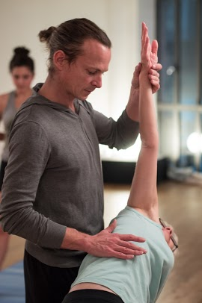
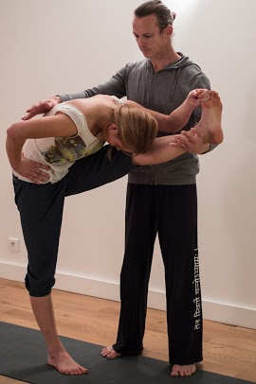
An Ashtanga Yoga Weekend
with Arnaud Kancel

Friday, May 23 – 25, 2014
in our rue Louvigny & av. M. Thérèse locations

FRIDAY EVENING - 18:30-20:30
"Pranayama & mantras"

SATURDAY MORNING 9:00-11:30
"Preparation for lotus"

SATURDAY AFTERNOON 14:30-16:30
"Hip opening and deep relaxation"

SUNDAY MORNING 9:00-11:30
"Vinyasa, approaching advanced postures"

SUNDAY AFTERNOON 14:30-16:30
"Adjustments and Alignment"

Visit the following webpage for more program details :

http://www.yoga.lu/events/28-ashtanga-yoga-from-the-sound-of-the-breath-to-the-silence-of-the-body

Price: 165 € before April 23rd, 180 € after;

Individual Sessions: 35 or 40 € for 2h or 2h30 sessions respectively before April 23rd, 40 or 45 € after;

Add 5 Euros if you have not attended another INFINY workshop in 2014 for INFINY 2014 membership.

Location: Friday – rue Louvigny, centre-ville location; Saturday & Sunday – av. Marie-Thérèse location (see yoga.lu)

Enrollment: Payment required to reserve your place. The payment is fully refundable if cancellation is done no later than April 23rd, 50% refundable until May 9th, and only if you find a replacement after May 9th.

“Ashtanga Yoga Weekend with Arnaud Kancel – May 23-25, 2014

Enrollment form - return this slip to INFINY a.s.b.l. by email (info@yoga.lu) or bring to class. You may also send by post : 25, rue Josy Welter, L-7256, Walferdange)

Last Name____________________________ First Name_________________________________

Tel (Home)____________________ Tel (GSM)____________________ E-mail _____________________________

Please place an « x » in the box or boxes below to indicate which sessions you will be participating in. Tabulate the amount due based on the date of your registration, and please add 5 Euros for INFINY 2014 membership if you have not yet attended a previous workshop in 2014 even if you are only attending a single session.

⁪ I will attend all 5 sessions Friday – Sunday (165 € before April 23, 180 € after)
I will attend the following individual sessions only : | ⁪ Saturday 14 :30-16 :30 (35 € before Apr 23, 40 € after)
⁪ Friday 18:30-20:30 (35 € before Apr 23, 40 € after) | ⁪ Sunday 9 :00-11 :30 (40 € before Apr 23, 45 after)
⁪ Saturday 9 :00-11 :30 (40 € before Apr 23, 45 after) | ⁪ Sunday 14 :30-16 :30 (35 € before Apr 23, 40 € after)

I have made payment of ________ Euros to INFINY a.s.b.l.
(account BILL IBAN LU56 0020 1875 9477 2200, Swift Code: BILL LULL).

Date___________________________ Signature_____________________________________

